
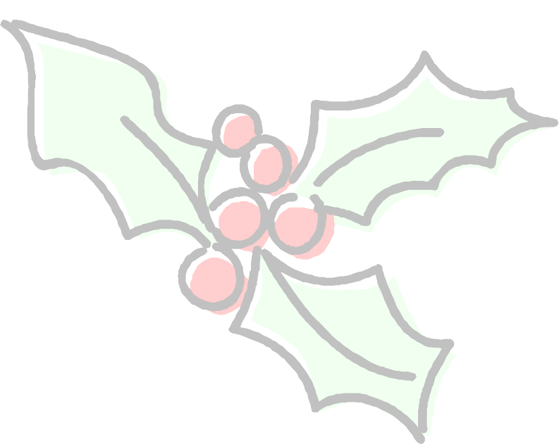
Wiltshire Community Web Online Newsletter

December 2006

Hello all and welcome to the third issue of the bi-monthly Wiltshire Community Web Online Newsletter.

Training Events Information

Free training events are continually being arranged for each area of the county. All dates will be advertised in future newsletter issues and in the news and diary sections of www.wiltshirecommunityweb.org.uk – keep checking back!

Current Events

Training Session | Tuesday 23rd January | 6-7.30pm | Calne Library, The Strand, SN11 0JU
Training Session | Monday 29th January | 5.30-7pm | Melksham Library, SN12 7DZ

PLACES ARE LIMITED: To book your place on a session, please contact Sharon Leney by email: info@wiltshirecommunityweb.org.uk or by calling 01380 722475

Hints and Tips

HTML - Hyper Text Mark-up Language. This is a programming language used to create web pages. The idea of WCW is that anyone with little or no web design knowledge can create a site. This can mean that the templates used within the site may be too restrictive for you to produce your own style for your pages. This is where a bit of HTML can help!

Changing Text Size
The templates use a set font size for your web pages, using the following tags can help you size it yourself! There are two methods for sizing your text:
- H1 – H6 tags
H1will make your text very large, H6 will decrease the size of your text. Simply insert the tag at the beginning of the text to be re-sized, and then place a closing tag at the end.

Example:
<H1> Text will be larger</H1>

<H4> Text will be larger than normal, but smaller than H1</H4>

- Font size tag
Inserting your own size for text can also be done using the font size tag. Again, insert the tag at the start of the text you would like to re-size, and then place a closing tag at the end.

Example:
<font size =”20”>This text will be very big</font>

<font size = “2”> This text will be small</font>

Coloured Text
The templates use black as the set colour for your text – using this tag, you can choose the colour you wish to use! Again this is similar to adding font size tags, insert the tag before the text you wish to be coloured and close it at the end. (Make sure you use the American spelling for colour – ‘color’)

Example:
<font color=”red”>This text will be red</font>

Top of WCW Search Facility

Ever noticed that when you use the ‘Search the Site’ option to search for community websites on Wiltshire Community Web, that the site results are not listed in alphabetical order?...This is because they are listed according to last updated!

This means that the more you keep your site updated, the longer it will remain at the top of the search results.
It does however only record this according to the homepage of your site. So make sure every time you make a change to one of your other pages, that you also upload your index page again as well –even if you have not made any changes. Simply open it to modify, but scroll to the bottom and select the arrow as normal.

Search the web for further HTML tips

Spotlight on a Wiltshire Community Web Site

Urchfont Community Web & Urchfont Parish Council

“To get involved with a web site or not to get involved with a web site…….that is the question !!

Earlier this year I started using Wiltshire Community Web to build two new web sites for the villages of Urchfont, Wedhampton and Lydeway.

The choice of Wiltshire Community Web was easy to make as it was readily available, simple to use, free and above all it works !

To start with I read the tutorial, spoke with Sharon a few times and set to work. I hope my experiences can help you.

A few thoughts…..

- spend considerable time at the design stage, it will pay dividends later on
- be clear about what information is to go on to the site
- know how it will look and the formats you will use
- ensure there is common understanding and acceptance of your approach, before you start work
- negotiate the freedom to edit or reformat .........conciseness is important
- put standard formats in place (Microsoft Word or PDF) so that the authors do the work….not you !
- use the advanced formatting explained in lesson 9
- if you want to use an existing domain name, a redirect can be put in place once your site is ready

Final thought…...if you are considering building a web site using the Wiltshire Community Web, what have you to lose ?

If all else fails press the delete key !

My thanks to Sharon and CravenPlan for excellent help and support!”

Yours Ian Maidment.
Visit their sites on Wiltshire Community Web:
www.urchfont.org.uk

http://www.kennet-communityweb.com/site/Urchfont-Parish-Council/index.htm

For each newsletter, we will feature a site that has been created on Wiltshire Community Web.

If you would like to have your site featured here in a future issue to promote your success, then get in touch!

Email us at info@wiltshirecommunityweb.org.uk with a short explanation of your site.

A ‘WCW Featured Sites’ list has now also been added to the homepage of each district site. Sites will be chosen every month to be listed here.

Editors Notes

Wiltshire Community Web is managed by Community First.

Community First is a charitable organisation that works at the forefront of community development to help improve the quality of life and economic well being of people and local communities throughout Wiltshire and Swindon

For further information visit our website at www.communityfirst.org.uk

Community First
Wyndhams
St Josephs Place
Devizes
Wiltshire
SN10 1DD Tel: 01380 722475 Fax 01380 728476

